**Issues observed while testing given scenario**

**Issue 1:**

**Title:** The Search results are not same while using same search criteria with different search options

**Description:** Search results page displayed after searching using (Type search text in search box+ select auto-populated text) is different from Search results page shown after searching using (Type search text in search box+ hit ‘Enter’ key)

**Steps to Reproduce:**

1. Launch Blinds.com in a web browser.
2. Enter ‘room darkening blinds’ text in Search box, select the auto-populated text as shown below:

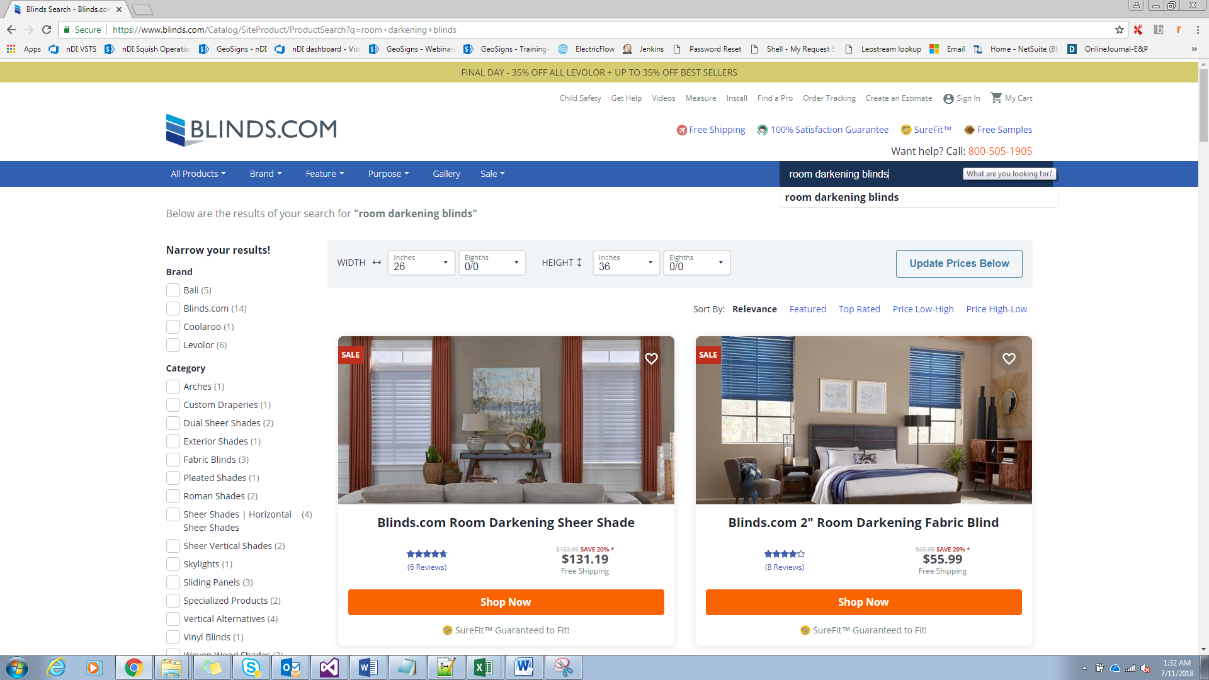

1. Search Results page displayed is as below:

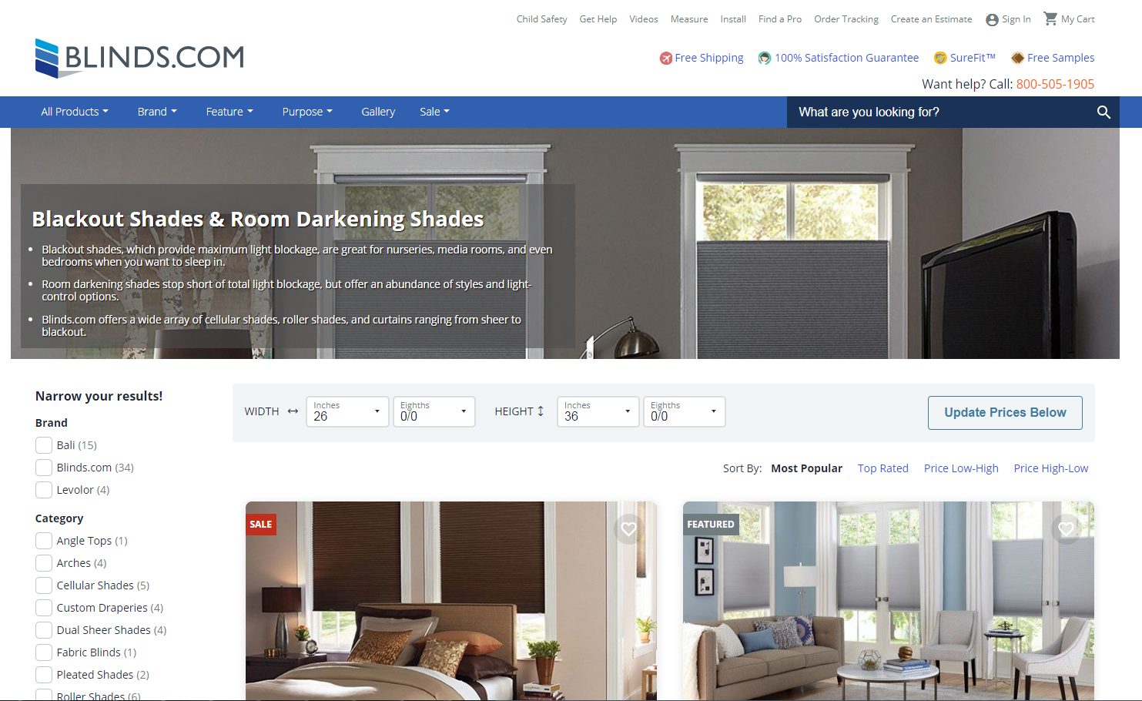

1. Now Enter again ‘room darkening blinds’ text in Search box and hit Enter key (don’t select the auto-populated text) as below:



1. Search Results page displayed is as below:

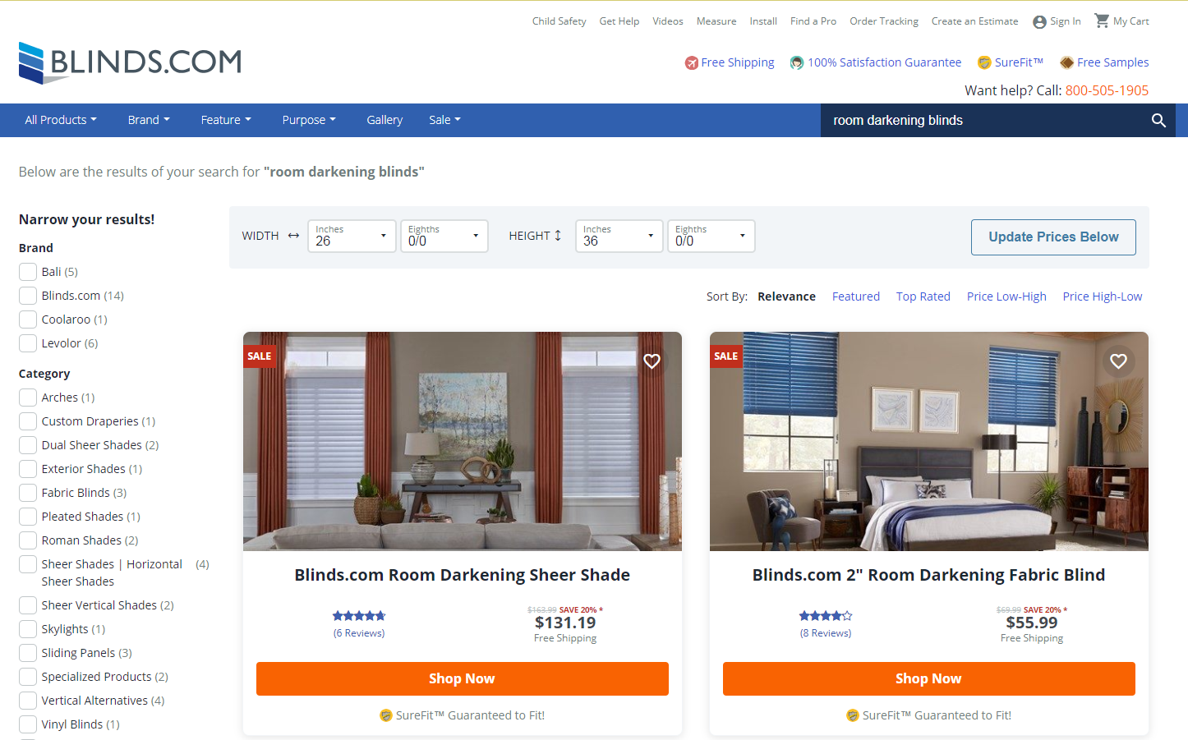

Notice the number of search results under Brand is different from what is displayed for the same search criteria in Step 3.

**Expected Result:** Search Results should be same for any searching style.

**Actual Result:** Search Results are different for different searching styles.

**Issue 2:**

**Title:** The Search results are showing ‘N/A’ for few items.

**Description:** Some of the items in the search results have ‘N/A’ as the price for the default dimensions of blinds

**Steps to Reproduce:**

1. Launch Blinds.com in a web browser
2. Enter ‘room darkening blinds’ text in Search box, select the auto-populated text.
3. Let the default dimensions of blinds remain as-is(Width: 26 inches/Height: 36 inches)
4. Sort the search results from ‘Low-High’ range.
5. Verify the search results after sorting as shown below:

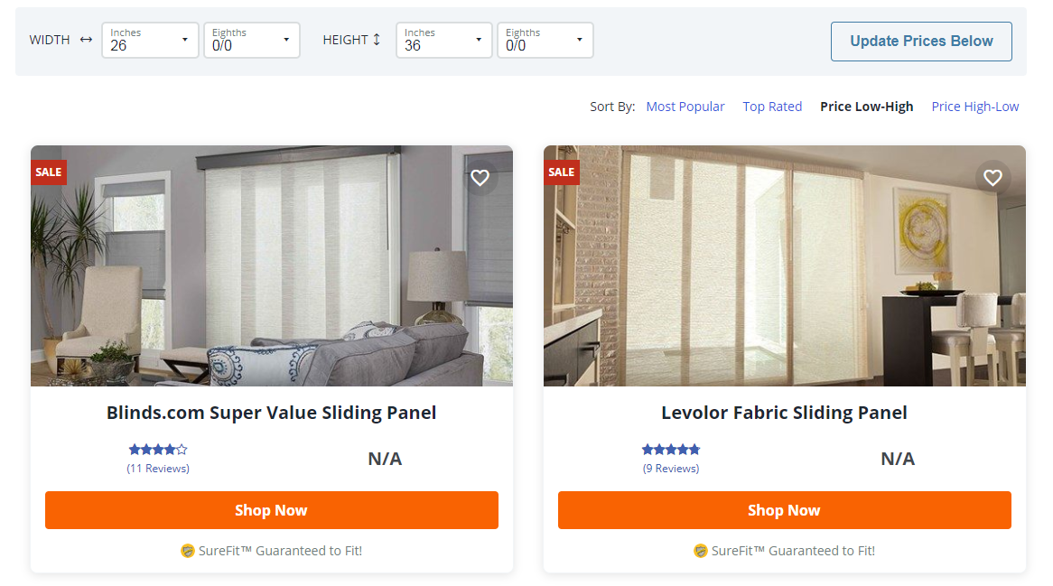

**Expected Result:** Search results should be shown only for the given search criteria and default dimensions

**Actual Result:** Search results are showing items with prices ‘N/A’ as they are out of range for the default dimensions loaded.